1. Use Selenium IDE to record a test that hovers over the 'Categories' menu on the Flipkart homepage and verifies that the dropdown appears.
Ans:

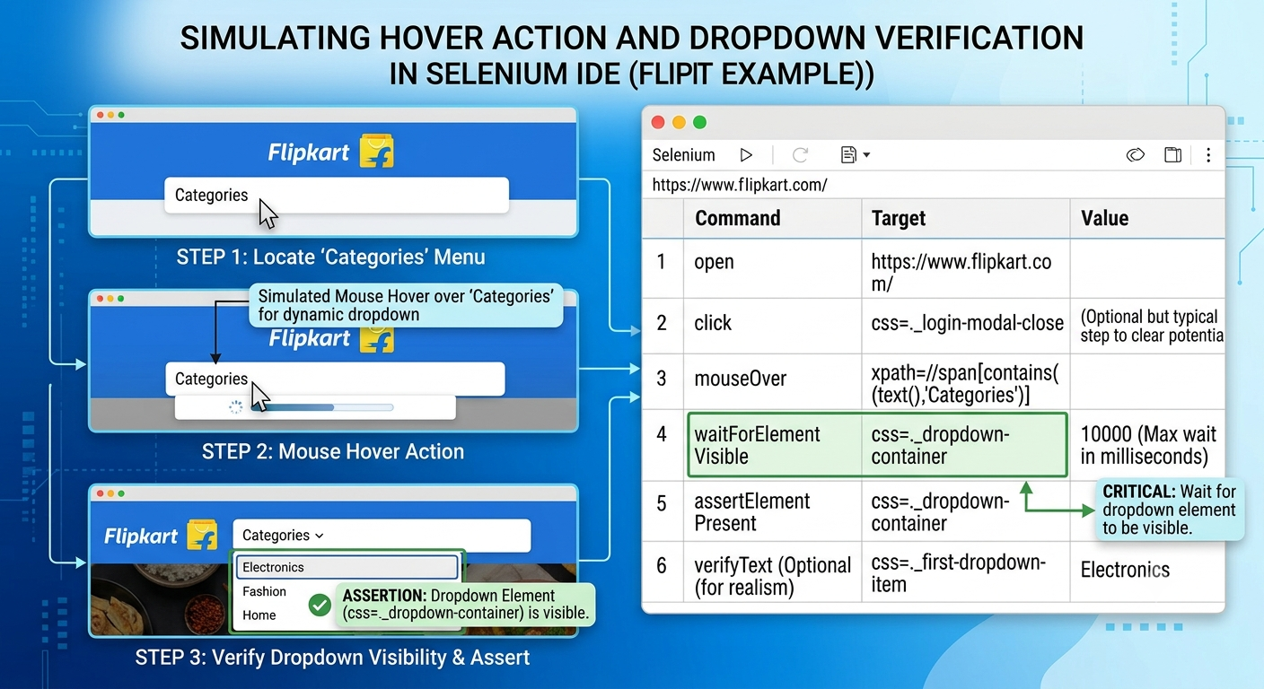

2. Install the 'UI.Vision RPA' Chrome extension and create a macro to perform a drag-and-drop operation on https://jqueryui.com/droppable/ by dragging the draggable box into the drop area. Use the extension's visual UI to select and move elements.
Ans
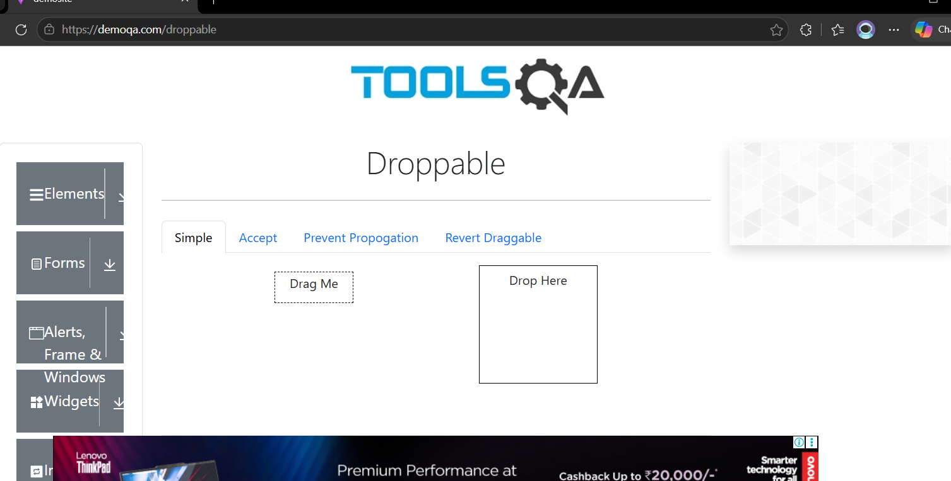

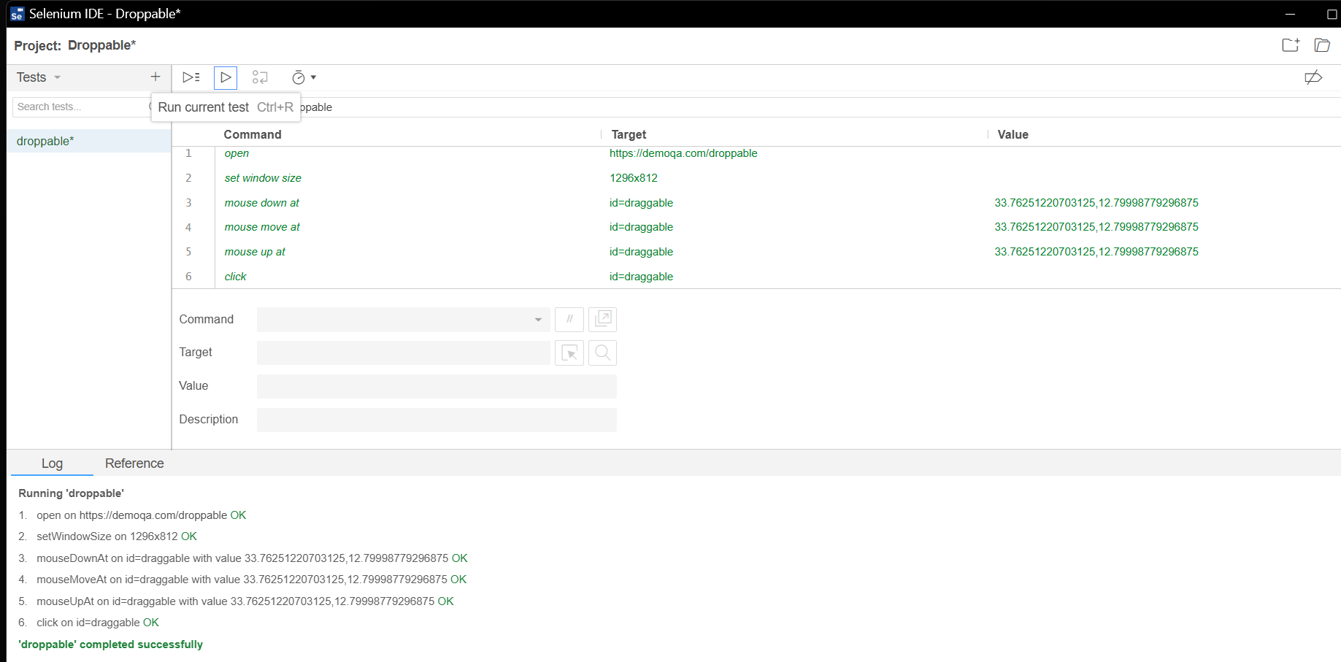

3. In Selenium IDE, automate a scenario where you use keyboard shortcuts to search for a product on Myntra: focus the search bar, type 'shoes', and press Enter to trigger the search.
Ans:
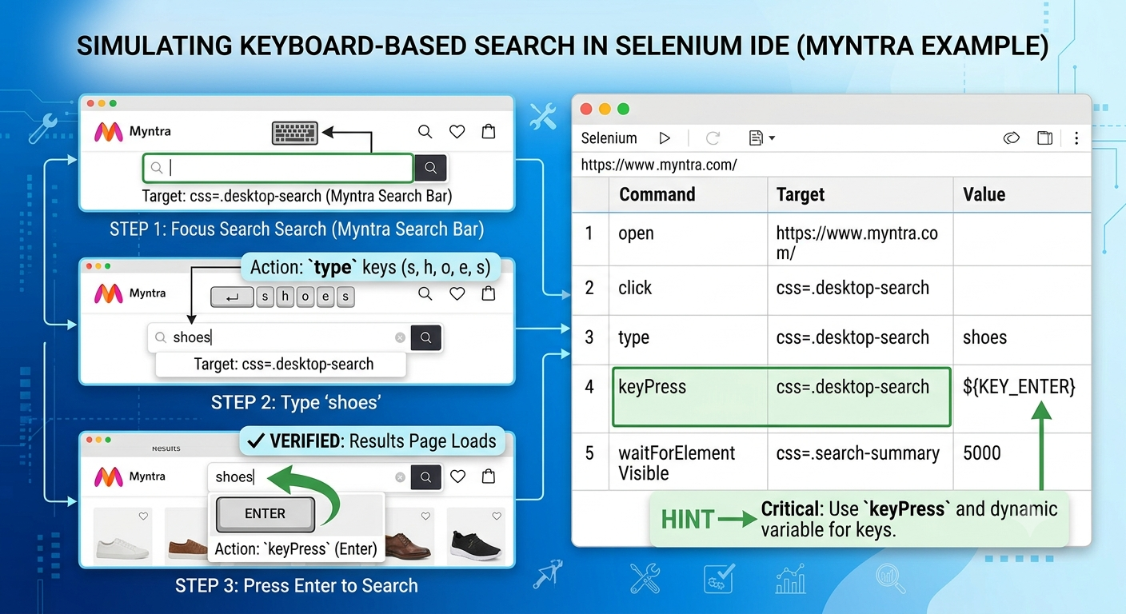

4. List 3 limitations you faced while trying to automate hover or drag-and-drop actions using only Selenium IDE or Chrome add-ons, and briefly explain how these limitations might affect testing real-world web apps.
Ans:
- Lack of Native Event Simulation: Extension-based tools trigger simulated JavaScript events rather than OS-level hardware mouse movements. In real-world apps with complex drag-and-drop or hover listeners (e.g., HTML5 native Drag and Drop, Trello cards, or interactive dashboards), these simulated events often fail to trigger hover states or complete drop operations.

- Timing and Frame/Viewport Boundaries: Hover menus and drag targets frequently rely on precise animation delays, scroll positions, or nested iframe structures. IDE commands like mouseOver or dragAndDropToObject often fail when elements are partially out of the viewport or inside dynamic iFrames, causing brittle tests on modern web apps.

- Flaky Record-and-Playback Capture: Selenium IDE struggles to reliably capture hover and drag-and-drop actions automatically during recording. Testers must manually insert mouseOver or coordinates, making script creation tedious and prone to missing intermediate hover states (such as multi-tier navigation dropdowns).

5. Use Selenium IDE to automate navigating the Zomato website's menu: hover over the 'Order Food Online' section, click on a cuisine (e.g., 'Pizza'), and verify that the results page loads.
Ans:
